**How a login system is working (spring security)**

**Story of Login in the System**

**Once upon a time, in the Clinic Management System, there lived users and roles.**

* **The Users table was like a guestbook. Every person who could enter the system had a record: their first name, last name, email, password, and a magical link to their roles.**
* **The Roles table was like a list of keys. Each key had a name: ROLE_ADMIN, ROLE_DOCTOR, ROLE_PATIENT. These keys decided what doors (pages, actions) a user could open.**

**The Hero (User) Enters**

**One day, a person named Alice wants to log in. She knows her email and password, so she goes to the login gate (login form).**

1. **The Gatekeeper (System) looks at her email in the Users table.**
   * **It finds her record: user_id = 101, email = alice@example.com. ✅**
2. **Password Check**
   * **The gatekeeper compares the entered password with the stored password. If it matches, Alice is allowed in. 🔑**
3. **Finding Alice’s Keys (Roles)**
   * **The gatekeeper now needs to know what Alice can do.**
   * **It looks at the user_roles table. This table is like a list of links between users and roles:**

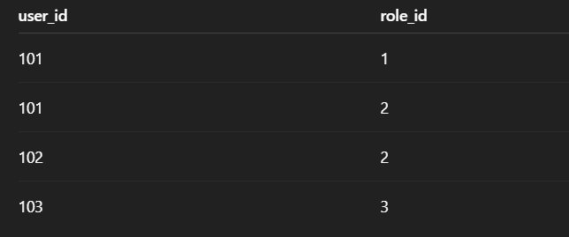

**Alice’s user_id = 101. The gatekeeper sees that she has role_id = 1 and role_id = 2.**

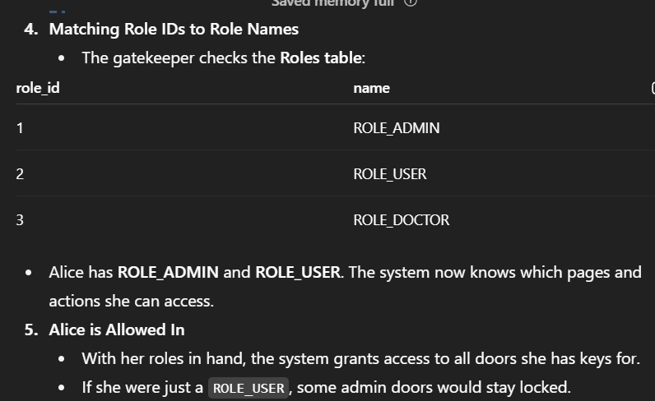

**Connection Between Tables**

* **users table → stores basic info and gives a user_id.**
* **roles table → stores role names and gives a role_id.**
* **user_roles table → a bridge that says “which user has which role”.**

**This is how one user can have many roles and one role can belong to many users.**